Authority Editor
Documentation
18 Jan 2026

Contents
Document purpose 2
Application overview 2
Installation 3
Source code 3
Compilation and Packaging 3
Compatibility with the original AE 4
Usage 5
Tree menu 5
Edit view 6
Source view 11
Review view 11
Apply Filter 11
Stylesheets 14
Editing the Application 16
Enhancement log 18

Document purpose
The purpose of this document is to provide a description of Authority Editor (2025/26 release) to support use and maintenance.

Application overview
Authority Editor is a GUI application for creating, editing and transforming retention and disposal authorities in an XML format. It fully implements State Records NSW’s XML schema for retention and disposal authorities.
Authority Editor replaces an original Ruby version of the application. This document describes the new version.
Authority Editor is written in the Dart programming language with the Flutter framework. The Windows distribution also has code written in Zig, with dependencies on the Libxml/Libxslt C libraries, for XML manipulation and XSLT transformations.

Difference between Windows and Web distributions
Authority Editor is distributed for Windows and web. Both distributions run locally and don’t need an internet connection to work (although the web version does need to be downloaded before it will run).
The distributions have different XML backends and only the Windows version is able to use XSLT to do transformations (for editing, HTML previews and DOCX exports). Also, because of the restrictions of running in a browser, the web version cannot save edits to arbitrary locations but can only write to the Downloads folder (using the “Download’ option in the File menu).

Installation

Windows
The Windows version of Authority Editor can be installed from the Microsoft Store: https://apps.microsoft.com/detail/9N3BXXQTLVLN?hl=en-us&gl=AU&ocid=pdpshare

Web version
The web version of Authority Editor can be accessed at: https://authorityeditor.com/nsw/
The web version can be installed as a local application by clicking on this the following icon in the URL bar:
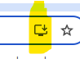

Source code
The source code for Authority Editor is available here: https://github.com/richardlehane/authorityeditor

Compilation and Packaging

Prerequisites
Authority Editor is a compiled application and requires the Flutter toolchain to be built.
Instructions for installing Flutter are here: https://docs.flutter.dev/install
For the Windows native version, the XML backend is written in Zig. It is unlikely that this backend will need to be rebuilt but, if needed, install Zig version 0.15.2 from here: https://ziglang.org/download/. The command for rebuilding the Windows dll is `zig build -Doptimize=ReleaseFast` (run from the /backend folder). Copy the new dll into the /frontend/assets folder.

Building for Windows
To build a Windows executable follow these steps:
- go to the \frontend folder (`cd frontend`)
- run `flutter pub get` (to install dependencies)
- run `flutter build windows` (this creates a new executable in the build/windows/x64/runner/Release folder)

Packaging for Windows
To build an MSIX installer for Windows:
- first, test the steps above to ensure it can be compiled
- go to the \frontend folder
- run `dart run msix:create`

Building for Web
To build the web distribution:
- go to the \frontend folder
- run `flutter build web --wasm` (this creates a new web distribution in the build/web folder)
- If the distribution is hosted at a subdirectory, e.g. “https://www.nsw.gov.au/departments-and-agencies/dciths/state-records-nsw/authority-editor`, use the base-href flag with the build command, e.g. `flutter build web --wasm --base-href “/departments-and-agencies/dciths/state-records-nsw/authority-editor/”`

Compatibility with the original AE
The new version of Authority Editor should be able to open all authorities written in the old version. Because some fields have been deprecated (e.g. Scope and certain Status events), this information may not display, however it will remain in the source document and can be checked by switching to Source View.
The old (Ruby) version of Authority Editor should be able to open most authorities written in the new version. However, any authorities that include the new “Amended” Status event will fail with a validation error. This is because the old version of Authority Editor validates files against the original XML schema that does not include this element.

Usage

Tree menu
The structure of the retention and disposal authority can be created using the left-hand tree menu in the edit view.

Details menu item
Left-clicking on the Details item selects the form to edit the top level details of the authority.
Right-clicking on the Details item allows you to add a function, activity and class in a single step.
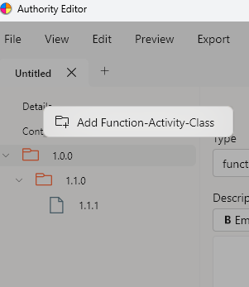

Context menu item
Context elements are used to add descriptive statements that provide supporting documentation for the authority, e.g. to include in an appraisal report.
Right-clicking on the Context item presents an option for adding a context element.
Right-clicking on Context element items presents additional options:
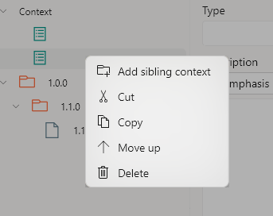
Term and class menu items
Right-clicking on Term and Class items presents a similar set of options. The Cut/Copy and Paste options work within documents and across open tabs (to copy content between authorities):
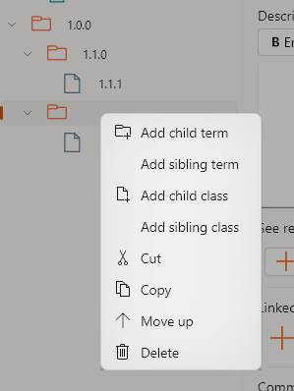

Edit view
There are four editing forms: Authority details, Context, Term and Class.

Authority details
The start date and end date fields in the Authority details page can be left blank to give an “Open” date range.
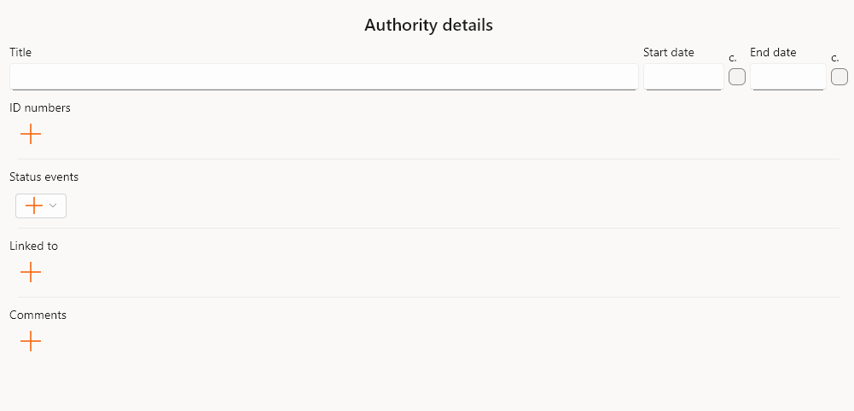
Selecting the “plus” icons adds elements where multiple entries are permitted (e.g. multiple IDs or multiple comments).
Authority Editor includes a new “Amended” status event:
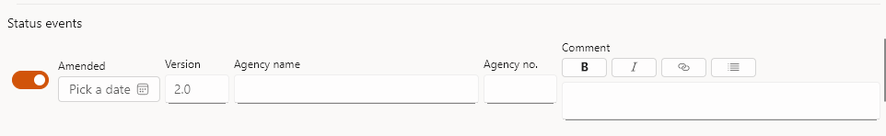
Right clicking on items in multiple lists allows those items to be moved or deleted:
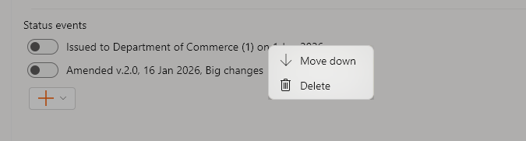

Context view

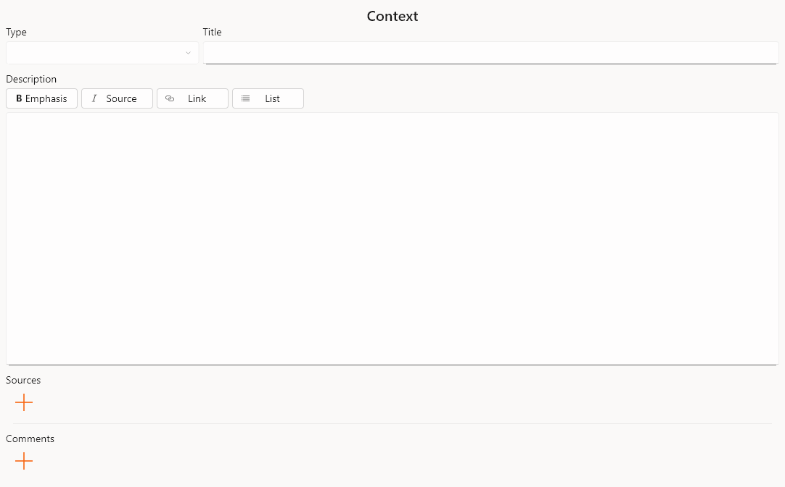
In the type field of the Context view any Context type can be given. Alternatively, a drop down menu can be selected with the options “background”, “issue” and “legacy”:
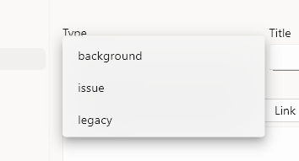
Background and issue context items populate the relevant sections of the appraisal report. The new legacy entry is added to support the amendment process. E.g. if an authority is amended, and it has an old background or issue already included, then you can change that old “background” context element to “legacy” so that the stylesheet will pick up the new and not the old one.

Term entry
In the new version of Authority Editor, the “type” field is automatically populated for new function and activity items based on their position in the hierarchy. This can be overridden.
The title field automatically uppercases text for function titles (this was an optional setting in the old version).
Internal See references are automatically populated with terms already in the authority.
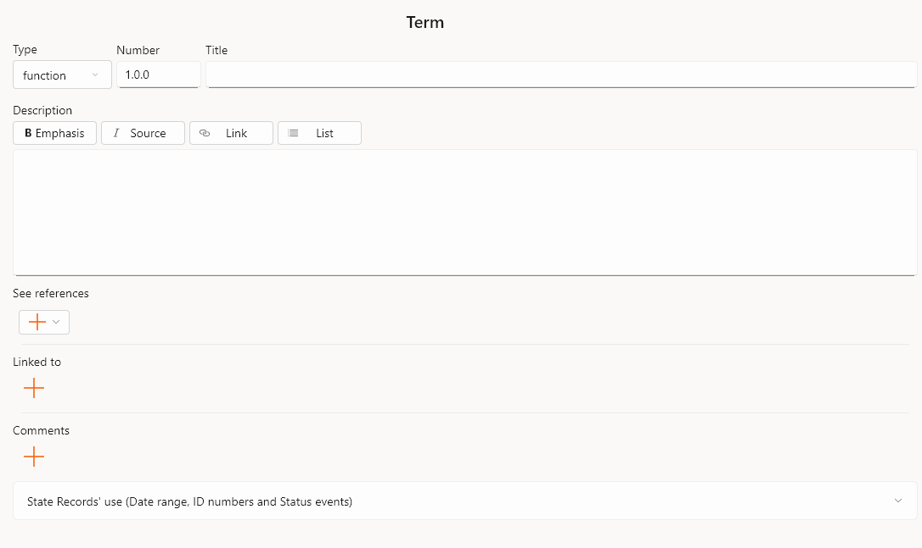

Class
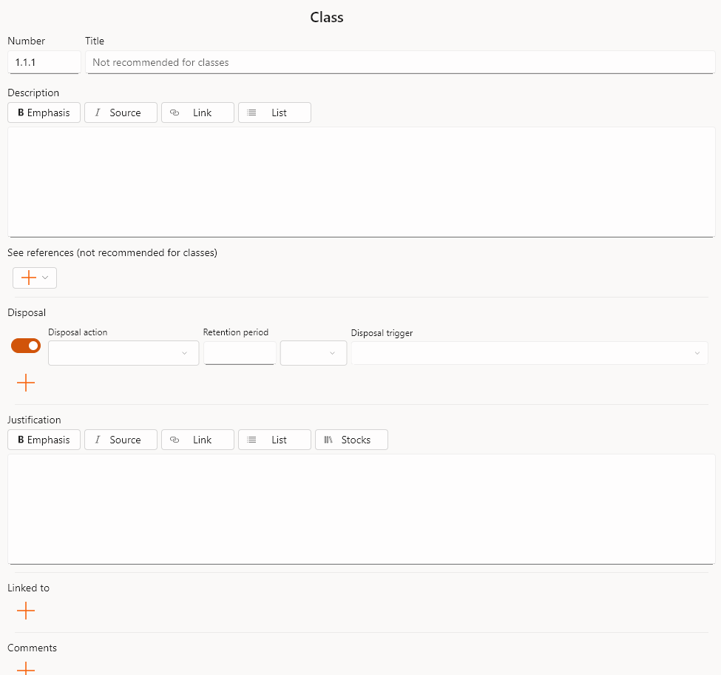
In the Class view, the new Disposal form is dynamic and changes the fields depending on the “Disposal action” selected. E.g. if “Required as State archives” is selected, no other fields are needed.

Undo/ Redo
When using text fields in the Edit forms (e.g. title, description, etc.), edits can be undone and redone using the shortcut commands: CTRL-Z (undo) and CTRL-SHIFT-Z (redo).

Source view
The source view (selected from the View menu) displays the XML source for the authority. This may be useful for debugging issues. This is a read only view.
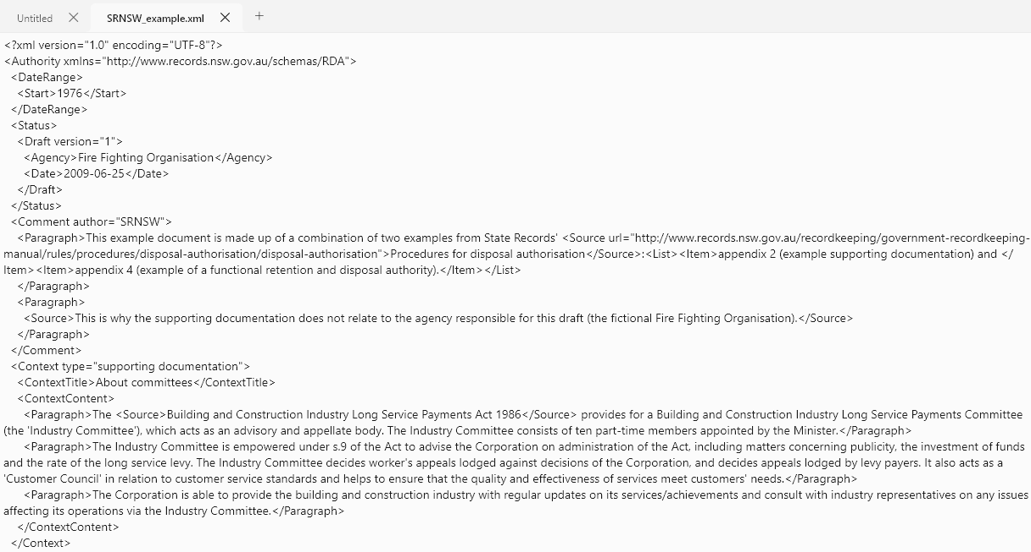

Review view
The review view (selected from the View menu) presents the authority in a readable form. While in the review view, you can jump back to the edit view for any particular entry by double clicking on the item.

Apply Filter
Authority Editor has a new filtering function that can be selected from the View menu. This opens a dialog where you can construct a filter query.
Filter queries can comprise multiple statements (connected either by “and” or “or” joins). Query statements can search against titles, text fields, item numbers, date of last update, retention period, disposal action, and comments.
Filters can be scoped to all terms and classes, just terms, or just classes.
The toggles at the top right control:
- whether the filter applies to the selected authority or across all open tabs
- the join method (or/ and)
- case sensitivity when matching text
- and whether descendants should be included in results (e.g. so you can search for a particular term and see all its descendant terms and classes in the result).
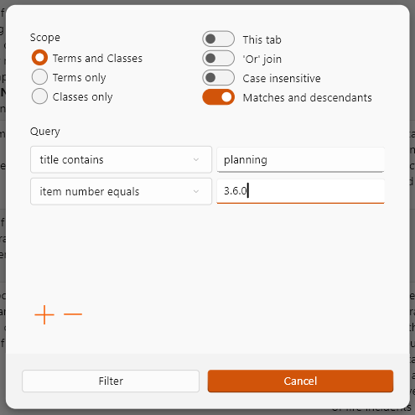
When a filter is applied, it takes effect across both the Edit and Review views and remains in place until the Trash icon is selected to remove it.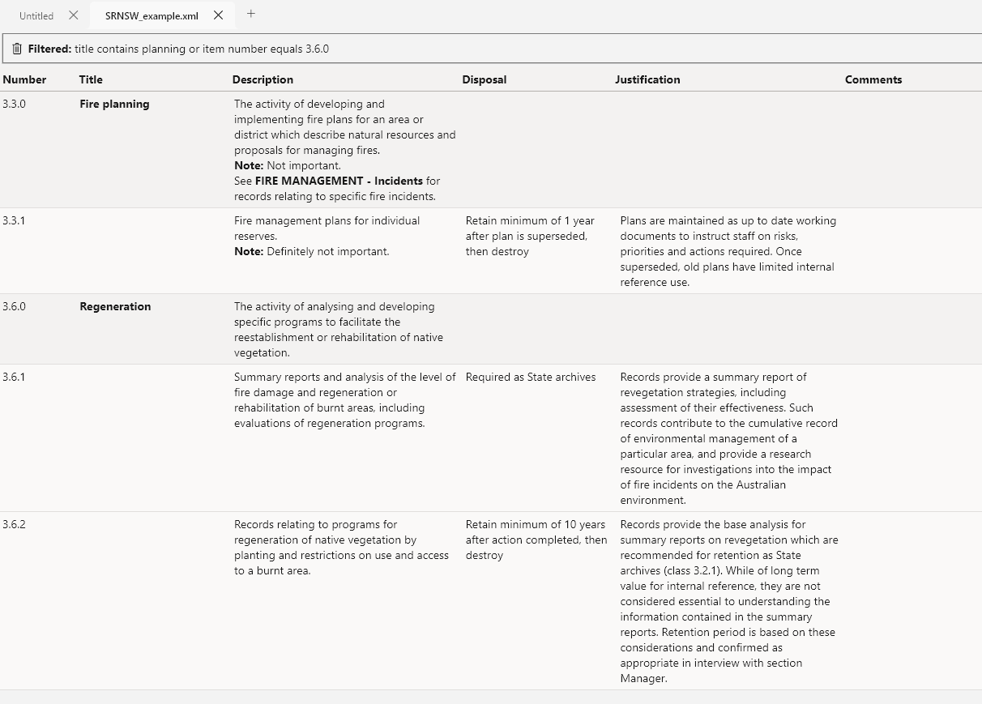
Filters combine particularly well with the Review view and can support a number of different workflows including:
- searching for particular terms or classes, within an authority, or across multiple authorities,
- focusing on the contents of a particular function(s) for close reading (by matching a term and retrieving descendants)
- reviewing all classes with a particular retention period (greater than/less than) or disposal action (combinations are possible too e.g. all retention periods over 50 years or with a Required as State Archives disposal action)
- viewing all content changes since a certain date
- viewing all content where comments have been made.
Note: If a filter is in effect and you select Apply filter an additional time, then the subsequent filter will further refine the already filtered content. Cancel the original filter first if you want a broad search.

Stylesheets
Stylesheets are only available in the Windows native version and are selected from the Edit, Preview and Export menus.
The Edit stylesheets use XSL transformations to run bulk editing tasks across authorities: e.g. sorting, numbering, clearing comments. A new “Sort linked tos” stylesheet has been added. This does a two level sort, first by type, and then by the contents of the field. Note: this sorting can create some distortions e.g. for SRNSW function and SRNSW activity linked tos, sorting by type can separate an activity from its function.
The Preview stylesheets use XSL transformations to create HTML documents that are opened in your browser. These are lighter weight than the DOCX transformations so can be a quicker way to preview an authority in document form. There are also some useful reports in the Preview menu such as reporting on incorrect internal See references (broken links).
The Export stylesheets use XSL transformations to create DOCX and TSV documents. The DOCX documents will open automatically in Word. The TSV (tab separated version) document can be opened in Excel but you may need to create an association first. If this is needed, you will be prompted to select the application you want to open the TSV file in. From that menu, browse to your Excel installation (if it isn’t in the list presented, find your EXCEL.EXE in the browse option e.g. at C:\Program Files\Microsoft Office\root\Office16). This normally only has to be configured once.

Appraisal report stylesheet
Fields in this stylesheet are populated according to these rules:
- Subtitle: AR number from the last ID with “AR”; Agency name in parens taken from the Agency on draft status element
- Folder: populated from the last ID with “SRFILENO”
- Background: populated from Context element with “background” type
- Submission: if there is an Amended status element, the text will have “Request for amendments to [ID with FA or GA control] covering [Agency name]”; if not, it will have “Request for approval of a retention and disposal authority covering [Agency name]”
- Issue: populated from Context element with “issue” type
- Attachments: AR number from last ID with “AR”

Approved stylesheet
Fields in this stylesheet are populated according to these rules:
- Cover page: FA or GA ID number in title; “This authority covers records documenting the function of [Authority title ]” (as Scope no longer used)
- Cover page: Version and date from the last Amended status event, or from Issued.
- Table: Authority number and SR file number from ID elements; Scope from Authority Title; Public Office from Issued elements; version as on Cover page
- Amendments table: version 1.0 is populated from the Issued element; subsequent amendments are populated from Amended elements
- Table of Contents: in the draft and approved authorities, a table of contents is inserted when there are more than 5 terms in the authority

Editing the Application

Editing stylesheets
Stylesheets may need to be updated over time (e.g. to update names of Manager and Executive Director). To update stylesheets:
- access the stylesheets by downloading the source files and navigating to the /frontend/assets/stylesheets directory
- make edits as needed
- either rebuild the application and create a new MSIX installer (see Compile and Packaging instructions) for distribution with your changes;
- or copy the edited stylesheets into the stylesheets folder on your PC (if installed via the Microsoft Store, the local folder is c:\Program Files\WindowsApps\RichardLehane.AuthorityEditor.VERSION.XXX\data\flutter_assets\assets\stylesheets) Note: accessing this folder requires administrator privileges.

Editing the application code
It may be necessary to make updates in the application code over time (e.g. to update the list of GA28 terms or to add a new stylesheet).
To make application updates:
- download the source files and make changes as needed to code in the /frontend/lib directory
- rebuild the application and create a new MSIX installer (see Compile and Packaging instructions).
Source files that may need to be updated over time:
- /lib/home/widgets/menu.dart: this file builds the application menu. If new stylesheets are added, they can be added to the Edit, Preview or Export menus by editing this file.
- /lib/edit/widgets/multi/ga28.dart: this file creates the See Reference form for GA28 references. GA28 terms are maintained in lists in this file (line 96 onwards) and can be edited here to change the dropdown menu.
- /lib/edit/widgets/multi/linkedto.dart: the drop down list of linked to types is defined from line 33.
- /lib/edit/widgets/multi/linkedto.dart: the drop down list of disposal triggers can be edited in this file (line 20).
- /lib/edit/widgets/markup/justifications.dart: the list of stock justifications is defined in this file (line 60 onwards).
- lib/edit/view/context.dart: this file creates the Context form. The list of Context types is defined at line 9 of this file.

Enhancement log
The purpose of this table is to capture suggestions for future enhancements to Authority Editor.
Change | Rationale
Performance
Authority Editor should now be reasonably performant however if users encounter issues with performance, there are some improvements that can be explored.
Flutter profiling | Performance of both the Windows and web versions could be enhanced by the use of Flutter profiling tools to identify hotspots and optimize code in hot paths, improve memory management, etc.
Multithreaded Windows backend | The Windows backend runs in the same thread as the main application process. It could be reconfigured to run on a separate thread (Dart isolate).  This would mean:  - an overall performance improvement (by spreading the application load over multiple processor cores)  - no more pauses or jitters in the frontend when running large XML tasks in the backend (e.g. big XSL transformations).
Web version
The web version lacks key features from the Windows version that are enabled via XSL stylesheets. Some of this gap could be remedied to make the web version more capable.
Edit stylesheets | Functions like sorting and numbering could be implemented in Dart code (rather than in XSL as at present). This would make key edit functions accessible in the web version.
Export stylesheets | It isn’t feasible to replace XSL for creation of the DOCX stylesheets as these are heavily customised. However, the tab-separated version export (that opens in Excel) could be implemented in Dart code. In doing so, it may also be possible to target XLSX as the output format, rather than tab-separated. It may also be possible to create a basic Word export for the web version.
Amended/ Context/ Justifications
Further uses of the new Amended status events and greater structure for justifications.
Amended events | The new amended events can be applied at the term/class level as well as at the top level of the authority. At present, only top level amended events are used in stylesheets (the appraisal report and approved authority).  Further stylesheet changes could be made if amendments are marked on terms and classes:  - to add footnotes on amended terms or classes (the amended comment could be used as the footnote text)  - to generate a table of proposed changes within the Issue section of the appraisal report (each row in the table could be generated from amended events applied at term or class level).
Context types | Additional context types for Consultation and Benchmarking could be added for inclusion within the Issue section of the Appraisal Report. This may improve formatting (e.g. subheadings).
Justifications | Justifications are more structured than they used to be with sections on Precedents, Benchmarks, and Building the Archives policy objectives.  Rather than including all this content in the existing Justification element, there are options to better structure it within the XML itself e.g. by:  - including this content as Linked To elements (if no schema changes desired)  - or enabling multiple justification elements to be added and adding a “justification type” attribute.
Additional Authority Editor Features
Additional feature enhancements may include the following:
Undo/Redo | Undo/Redo only works at present within individual text fields.  Additional actions could have undo/redo support: deleting nodes using the tree menu; copying/cutting/pasting nodes using the tree menu; applying edit stylesheet transforms
Search filters | As the new Apply filter functionality gets used it may turn out there are other ways that users want to find terms or classes (e.g. by searching for text that doesn’t contain a keyword etc.). This new feature is flexible and new types of search statements can be added if needed.
Spell check | Spell check functionality could be added to description and text fields to highlight spelling mistakes.
Warn on unsaved changes | At present the application tracks whether changes have been made to documents but it doesn’t block the application being exited with unsaved changes. This feature could be added.
Customisable views | Users may have specific preferences re. layout and height of fields (e.g. to make Description fields bigger or smaller). A user settings page with options to make customisations to layout etc. could be added.
Editing options in Review view | The Review view is currently read only. To make any changes, users need to double-click on entries to return to the Edit view. Some options to make updates within the Review view could be added (e.g. right-click to add Comments).
Online services
Outside Authority Editor, additional online services could be developed to utilize the value in XML authorities.
Online search and publication | An online publishing tool could simplify the task of publishing authorities online and make them more discoverable. Such a service could enable agencies to search within authorities that apply to them (i.e. their own FA and relevant GAs). A rich search would be able to display results at the class level and take advantage of full-text as well as content in index linked to elements.  An online search and publication service could also improve machine readable access to XML authorities by providing APIs for integration and a Model Context Protocol (MCP) server to enable LLM tools to perform structured queries for relevant disposal classes.
Online editing workflow | The web version of Authority Editor could be extended to provide an online editing environment (like ORDA). This would entail online hosting of draft authorities, online XSL transformations (which would be possible on a server), workflows linked to status events, and email notifications.

